Senay Leul Kahsay
DATA 205-33155
Spring 2026
Professor Perine
An Analysis of Car Crashes in Montgomery County, MD
Introduction/Overview
The two datasets I used for my capstone project are called Crash Reporting - Incidents and Crash Reporting - Drivers data. Both of these open-source datasets are from Data Montgomery. The datasets are updated each week since January 2015 and are collected via the Automated Crash Reporting System (ACRS) of the Maryland State Police and reported by different agencies such as Montgomery County police, Gaithersburg Police, and Rockville Police. The Incidents data consists of 120,000+ rows (each row is a collision) and 37 columns of information surrounding the incidents. Similarly, the Drivers data has 210,000+ rows (each row is a driver involved). It is important to note that these datasets are based on preliminary information that may change upon further investigation.
The foundational goal of my capstone project was to statistically analyze collision incidents to uncover underlying factors that are in play and to ultimately reduce the number of lives being claimed by car collisions. Additionally, the second goal I had was to contribute to Maryland’s Vision Zero initiative, which aims to entirely eliminate car related deaths by 2030. These goals are extremely important because the only acceptable number of car-related deaths is 0.
The main tool I used is python through Google Colab and the various libraries such as pandas, matplotlib and sckit-learn. Also, I used Tableau for mapping and dashboarding. The techniques I used involve Exploratory Data Analysis, Statistical Analysis, and predictive modeling.
Data Cleaning/Ingestion
To load in the data, at first, I simply downloaded the csv file of the datasets and uploaded it into the runtime session. However, after some time I realized that this is inefficient for two reasons. Firstly, since the data is updated each week, I would miss out on the latest data available unless I tirelessly downloaded and switched the data each week. Secondly, the data is quite large which resulted in a longer wait time while uploading it to the Colab runtime session. Therefore, I later switched to using API calls instead.
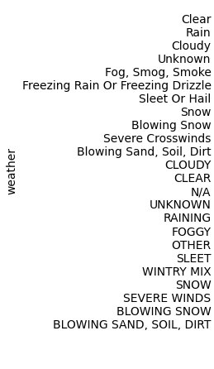
The only area the data needed cleaning was the categorical values of some columns. There were different redundant versions of the values, either with different capitalization or different wording. For example, looking at the categorical values for the ‘Light’ column we can see that there are a lot of duplicates like ‘Clear’ and ‘CLEAR’ with different capitalization or ‘FOGGY’ and ‘Fog, Smog, Smoke’ with different wording. To deal with this issue, I first converted the values of such columns into lowercase (using for loops and the .str.lower() method) which halved the number of them. Then I manually generalized and combined values by using the .replace() method which greatly reduced the number of values making it fit for analysis. Regarding N/A, ‘unknown’, or ‘other’ values, I only dropped them when doing my statistical analysis.
Basic Descriptive Statistics/EDA
As mentioned before, the Incidents data has 37 columns. These columns have details on the investigating agency name, outcome type, date/time down to the minute, road name, weather, light, surface conditions, and collision type. While there are many other columns, these are the most important ones I used in my analysis. On top of these columns, I also used other columns like vehicle movement, injury severity, and damage extent of vehicles from the Drivers data which has 39 columns. Moreover, the data contains latitude and longitude coordinate location for every incident which I used for mapping in Tableau. The two datasets have a very big overlap of columns but they also each have exclusive information that’s only present in either of them. These datasets can be joined by the ‘Report Number’ which is a unique identifier assigned to each collision. Notably, the Drivers data has almost double the number of rows as the Incidents data because one incident can involve multiple drivers. So, there is a one-to-many relationship between Incidents and Drivers data.
The following simple count plot alongside many others in the code tells us a lot about car crashes in Montgomery County and how this data is imbalanced. This plot shows us that the overwhelming majority of car collisions in MoCo result in property damage which compared to fatal and injury crashes, is a better outcome. An important thing to point out is that this count plot is for incidents, so it does not reflect the actual number of drivers involved, which is higher.
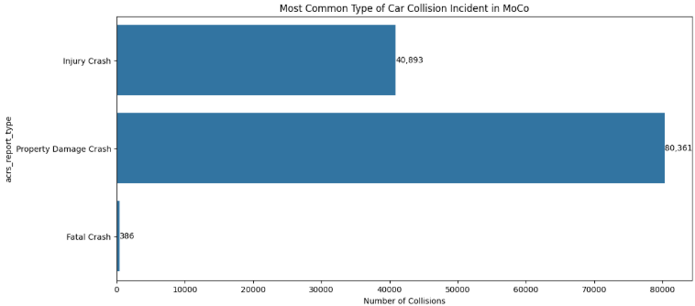

Analysis Results
I started off my analysis by identifying the top 10 roads with the most incidents in MoCo and found that Georgia Avenue had the highest count of property damage, injury and fatal crashes followed by New Hampshire Avenue second and Frederick Road third. My theory on why these roads experience such a high number of collisions is because they are the county’s major arteries and are surrounded by commercial hubs. This provides us with a foundational knowledge of where most car crashes happen and the areas we might need to focus on. So the more the number of cars, the greater likelihood of more crashes.
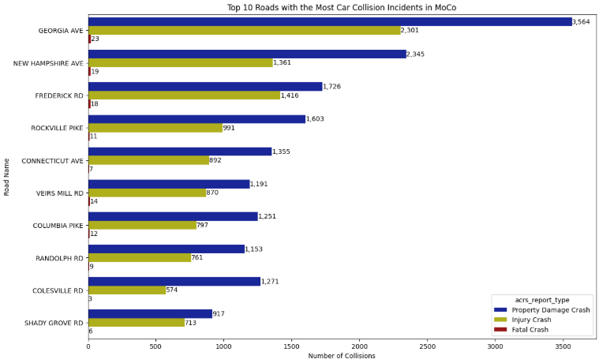

Next, to gain an understanding of what the number of collisions looks like over time, I made a time series by monthly count starting from January 2015. The first thing we notice when looking at this time series is the sudden drop of collisions in early 2020 which was due to the COVID-19 pandemic. Next thing we can observe is the constant repeating fluctuations. Almost all of the peaks are in October and almost all troughs are in February. There is no definitive answer for this, but I think October consistently having a high number of crashes could be the result of wet leaves making it easy to lose traction, earlier sunsets reducing visibility, autumn-inspired activities bringing in a lot of tourism, or even Halloween pedestrian traffic. On the other hand, the reason why February is consistently seeing low incidents could be because winter weather forcing people to drive more carefully or even because of Road Safety month. There is an interactive version of this plot in my code to better explore each fluctuation.
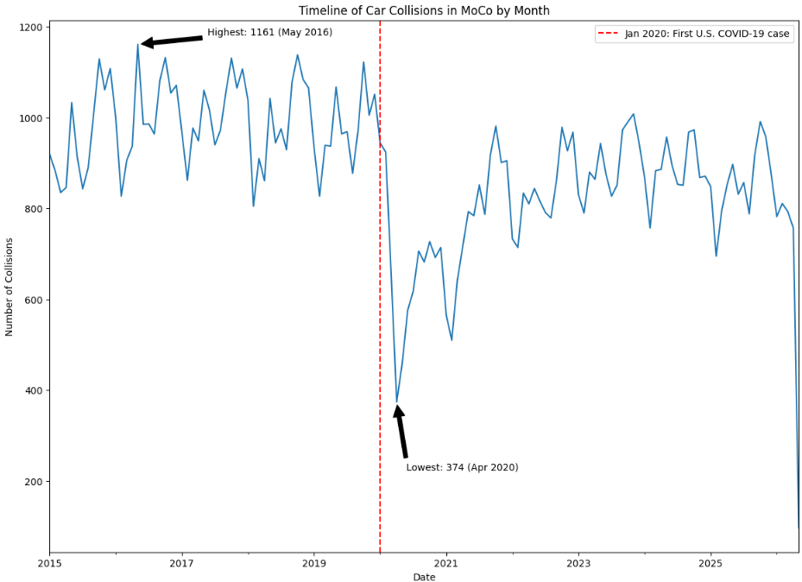

Next, I decided to break down the time series by doing a structural decomposition using an additive model. The first subplot shows the original time series I attached above. The second subplot shows the general trend or the long-term direction of the data. In this subplot, we can see the huge dip caused by the pandemic even more clearly. The third subplot, which is the seasonal, shows the annual recurrent and regular fluctuations of peaks and troughs. The final subplot shows the residual of the time series which tells us about the random, unpredictable, or noise variations remaining after the trend and seasonal components are removed. For the first two subplots the y-axis reflects the number of monthly collisions. However, for the last two subplots the y-axis has positive and negative values. In the Seasonal component, the positive values show that for a specific month the actual number of collisions is typically higher than what the long-term trend would suggest, after accounting for random fluctuation. The negative value shows the collisions are typically lower.
In the Residual component, the positive values indicate that for a specific month, the actual number of collisions was higher than what was predicted by combining the trend and seasonal components. It basically shows an unexpected increase. The negative values show the opposite; the collisions were lower than predicted by the trend and season components. There is an interactive version of this in the code.
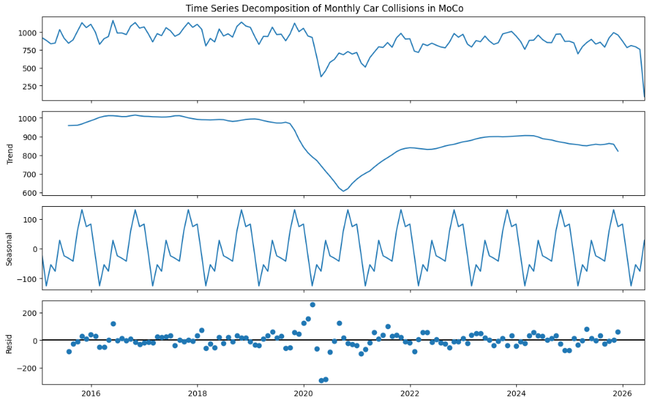

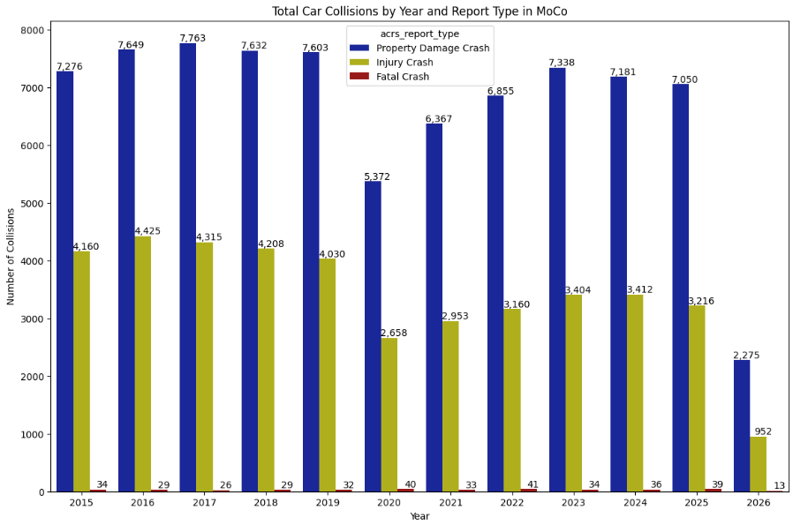
On the topic of time, I made a count plot showing the total aggregated number of collisions for each year and added color to represent outcome type. As we can see, 2016 had the highest total number of collisions, closely followed by 2017. The dip in car collisions for 2020 is visible here too.

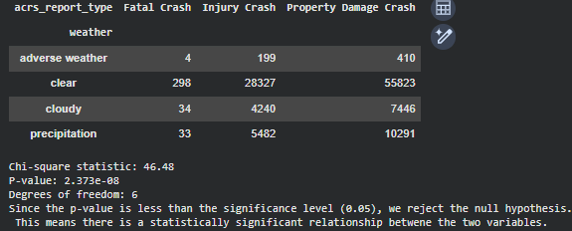
For my Chi-Square test I performed a dependency test between weather and outcome type. The P-value turned out to be very small meaning there is a statistically significant relationship between the two variables.

Finally, I made a Random Forrest classification predictive model that uses weather, light, surface condition, collision type, day of the week, and hour to predict the type of outcome for the Collison. The model is doing a good job identifying ‘Property Damage’ crashes, but it performs poorly for ‘Injury’ crashes and completely fails for ‘Fatal’ crashes because of the severe imbalance of the data. The following confusion shows this. The model predicted 0 as fatal crash, 25 falsely as injury, and 51 falsely as property damage. Additionally, the model correctly predicted 1,986 injury crashes out of 7,669 actual injury crashes but misclassified 5676 as property damage. More impressively, the model correctly identified 10,962 out of 13,645 actual property damage crashes while a little amount was misclassified.
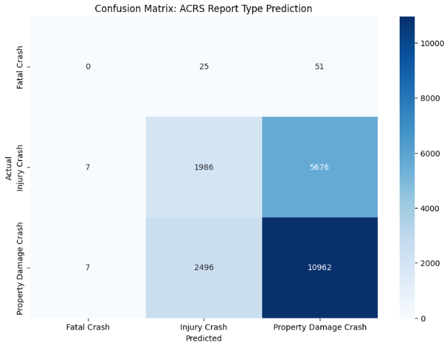

Dashboard Link
References
YouTube Videos
- Chi-square test: https://youtu.be/Jb9sxlnhZMo?si=dsUfz-Po4oJa0FbJ
- Classification: https://youtu.be/QM0sYbEQSkM?si=kVjgDe0H8WPyN72w
- Car crash prediction: https://youtu.be/beYlqRLmBjo?si=2qb9eqKStllwP_Kd
- One-hot encoding: https://youtu.be/G2iVj7WKDFk?si=9xH0yJR6ITFD2m42
Time series analysis
https://nicolarighetti.github.io/Time-Series-Analysis-With-R/structural-decomposition.html

Acknowledgments
Special thanks to:
- Professor Perine
- Professor Saidi
- Professor Alraee
- Other MC faculty
- Classmates

